Overview
The Annual Compensation Planning process provides managers with the opportunity to plan market adjustments, performance ratings, merit, bonuses, promotions and LTI for their teams.
We are using SecureSheet to collect our compensation data this year. SecureSheet allows you to enter information for your team in a secured application and it looks like Excel. You will only have access to employees you are authorized to and will only be able to enter information where required.

SecureSheet Workflow
- Managers need to submit/approve their recommendation before the next level manager can take action.
- Managers can make recommendations until their deadline date, then the worksheets will be rolled up to the next level managers. Each level will no longer have access to make changes beyond their deadline date.

Planning Timeline
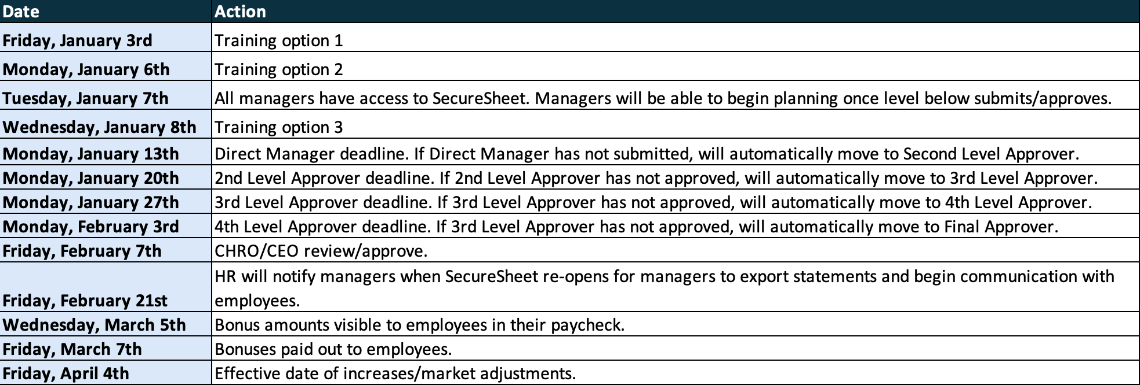

Logging In
Follow these instructions to login to SecureSheet:
<IF you are using SSO, tell them where to access SecureSheet – intranet site, etc.>
<If you are not using SSO, share the login instructions below>
Logging into SecureSheet for the first time:

- Click here to access the SecureSheet login page: SecureSheet login page.
- Click Forgot your password? or this reset password link.
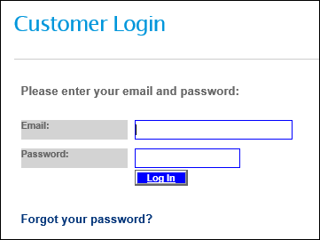
- Enter your Email address and click Reset Password.
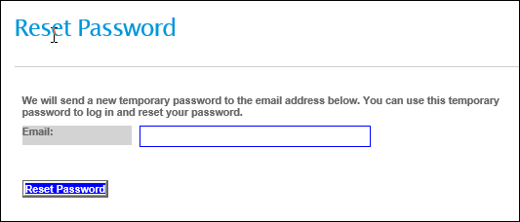
- Check your email for a temporary password.
- Go back to the SecureSheet login page.
- Enter your Email address in the Email field.
- Enter the temporary password you received in the Password field.
- Click Log In. Follow the prompts to set your permanent password.

NOTE: IF you forgot your password, you can reset it by clicking this reset password link, or by clicking ‘Forgot your password?’ on the SecureSheet Login screen.
- After you login, click the SecureSheet name to access your SecureSheet:

Planning in SecureSheet

Market Adjustments
The purpose for a market adjustment is to bring an employee's compensation closer to the salary range midpoint. An employee may be eligible for a market increase if their current salary is greater than 5% less of the salary range midpoint. Each eligible employee will be given a market adjustment budget %, with a maximum of 2% of their current salary. The market adjustment is separate from the performance-based merit increase.
- If an employee is not eligible, you will be unable to enter an amount.
- If the employee is eligible, enter an amount in USD to the Market Adj $ (USD) column
- Click the red Save Changes button.
- After you click Save Changes:
  - The amount in local currency will populate in the column to the right of the input column.
  - If you go above the budgeted amount, the amount will show in red font. Please stay within budget.
  - There’s a budget runner at the top of the sheet to show whether or not you’re within your overall budget.
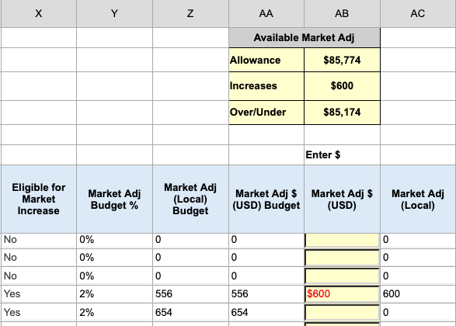

Performance Ratings
- Select Exceeds, Meets or Below from the Rating dropdown for each employee.
- After you clicked the red Save Changes button, the rating will fill with the corresponding color listed below:
  - Exceeds: Green
  - Meets: Blue
  - Below: Red
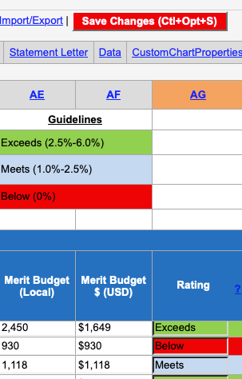

Merit Increases
Merit increases are to be awarded to employees based on their individual performance. By aligning merit increases with performance ratings, our organization can ensure that pay differentiation is fair, motivating and supports our overall business objectives.

Merit Guidelines:
- Employees rated as Exceeds should receive a merit increase between 2.5 % - 6%.
- Employees rated as Meets should receive a merit increase between 1% - 2.5%.
- Employees rated as Below should not receive a merit increase.

Entering a Merit Increase into SecureSheet:
- Increases must stay within the merit guidelines outlined above.
- Please stay within budget. Above the planning columns, you will see the available merit pool for your team.
- Increases may be entered as a percentage or dollar amount (in USD) and NOT both.
  - If you enter both (% and $), SecureSheet will stop you from saving the change and you must remove one (% or $) and click Save Changes again.
- Increases can’t be entered for employees who are not eligible (see Merit eligibility column).
- After you enter a merit increase and clicked Save Changes, you will see the local and USD amounts calculate to the right.
- Any merit increase that puts the employee above the range maximum will be paid as a lump sum. Employees will receive up to the range maximum as a base salary increase and anything beyond that will be paid as a lump sum (Current Salary + Increase – Max = Lump Sum Amount).
  - An employee could receive a lump sum and salary increase. For those individuals, the total amount added to their salary plus the lump sum will be the total amount that was planned for merit.
  - Most employees will not reach range maximum and the planned merit amount will be added to their base pay (no lump sum).
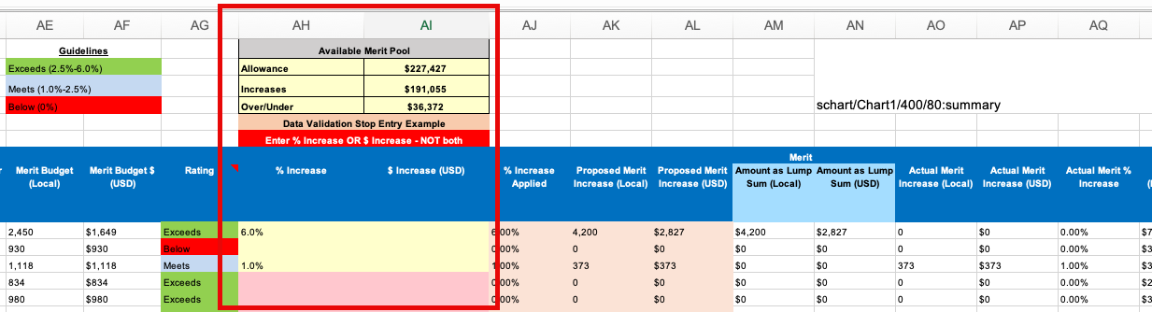

Promotions
Promotions are an important part of employee development and recognition. This process is designed to ensure fairness, consistency, and alignment with organizational goals.

Entering a Promotion into SecureSheet:
- Only employees who are flagged as ‘Yes’ in the Eligible for Promotion column may receive a promotion.
- Select the employee’s promotion department, whether or not it is changing, and click the red ‘Save Changes’ button.
- Select a new title for the employee. This list will be based on the department that is chosen for the employee within the promotion section.
- Enter a promotion increase percentage for the employee.
- The promotion increase amount will calculate after you enter the increase percentage and click the red ‘Save Changes’ button.
- Bonus eligibility and bonus target percentage will automatically populate once you choose a new title for the employee.
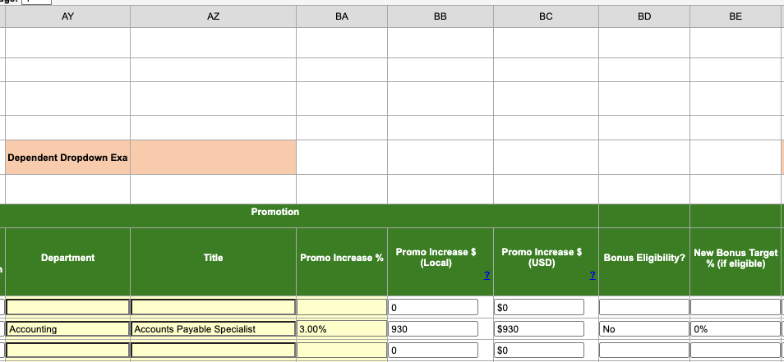

Bonus
Bonus is a form of variable compensation awarded to employees based on their individual performance. An employee’s bonus is contingent on achieving specific performance results, defined in advance and aligned with organizational goals.

Entering an Individual Performance Multiplier % into SecureSheet:
- Please stay within budget. Above the planning columns, you will see the available bonus pool for your team.
- The Target %/target amount is prorated based on hire date.
- Individual Performance Multipliers percentages above 100% require a comment. Enter the comment prior to hitting Save Changes in SecureSheet or you will receive an error alert and your change will not be saved.
- Individual Performance Multiplier % can’t be updated for employees who are not eligible (see eligibility column).
- Once you’ve entered a multiplier % and clicked Save Changes, you will see the local and USD amounts calculate to the right.
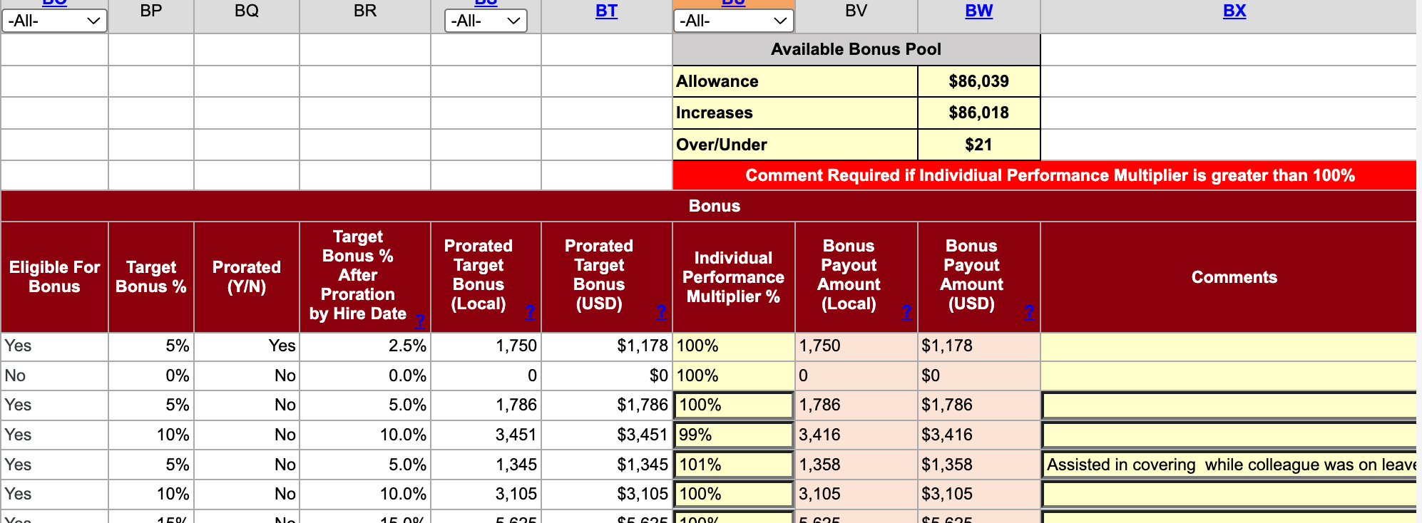

LTI
The LTI Plan is designed to reward eligible employees for long-term performance and to align their interests with the sustained growth and success of the company.

Entering an LTI Award into SecureSheet:
- Please stay within budget. Above the LTI Award column, you will see the available LTI pool for your team.
  - Note: LTI awards are planned in USD only.
- Only employees who are flagged as ‘Yes’ in the Eligible for LTI column may receive a LTI award.
- Eligibility and the LTI target % are based on job title.
- Award amounts are planned in USD.
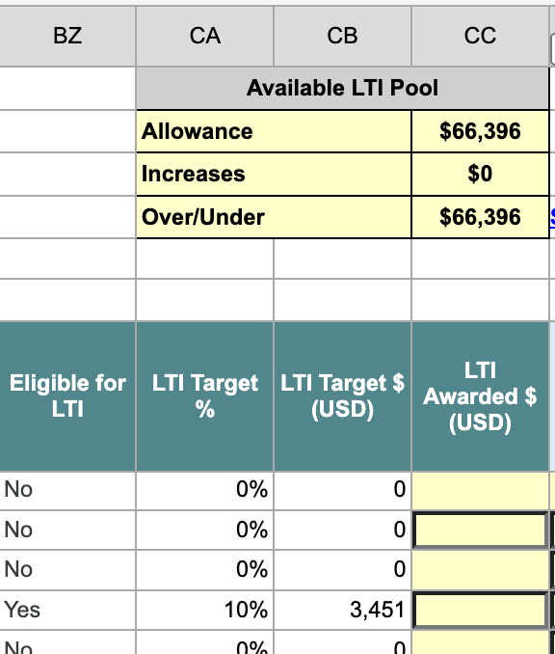

Submitting/Approving Recommendations
After you are finished entering your recommendations, submit/approve so the next level manager may approve.

Notes on Submitting/Approving in SecureSheet:
- You may Submit/Approve all recommendations at one time by clicking the Submit All/Approve All link.
- To submit/approve an individual row, select Submitted/Approved from the dropdown in the approve column, then click ‘Save Changes’.
- After you submit/approve, you will be locked from making further changes and the row will unlock to the next level manager.
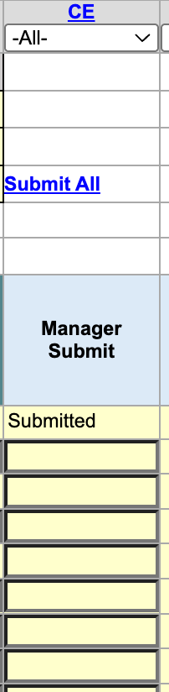

Navigation Tips
SecureSheet is an online spreadsheet customized for you to securely collect data from multiple colleagues simultaneously. If you have ever used a spreadsheet, there are many similarities to the look-and-feel of SecureSheet. Because SecureSheet is a safe, secure business application, it is set up for your business with specific rules and security settings. These navigation tips will help you get familiar with what to expect as a SecureSheet user.

Top Right Navigation
- Click <<Go Back to navigate to a previous window in SecureSheet. The browser back button should not be used to navigate when you are working in SecureSheet.
- Click Refresh to reset multiple filters you may have selected while working in SecureSheet. If you have more than one filter on, this will refresh to show all the data you are able to see in your view.
- Click the Zoom drop-down to increase the font in your SecureSheet window.
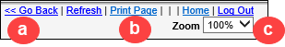

Moving Between Views
Select the “View” drop-down to see alternate views of the SecureSheet. A drop-down will only appear if you have been given access to more than one view.
- To access an alternate view, select a view from the View drop-down list.
You will see the what this view shows. Remember, not everyone has permission to see more than one view; it is based on your role in the process.
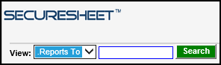

Filters
When a filter is applied to a column, there will be a drop-down below the column ID. Click the drop-down and select from the filter.
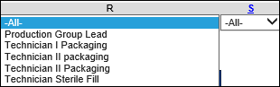

Sort
When a sort has been applied, the Column ID will be underlined in blue. Click the underlined Column ID to sort.
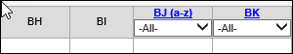

Export View
Click Export View to export the data in your current view to Excel. Follow the prompts that appear.

Save Changes
Always click to save any changes you made to the SecureSheet.

Additional Instructions
Add other specific steps / notes for your end users.

